Communication and Network Fundamentals project.
” Smart cinema for displaying movies"

Configuring details:
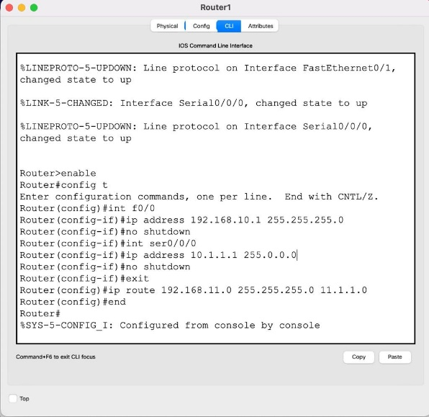
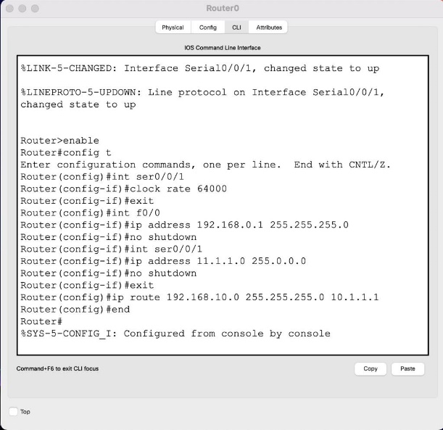
Fig 2 Router1
Fig 1 Router0
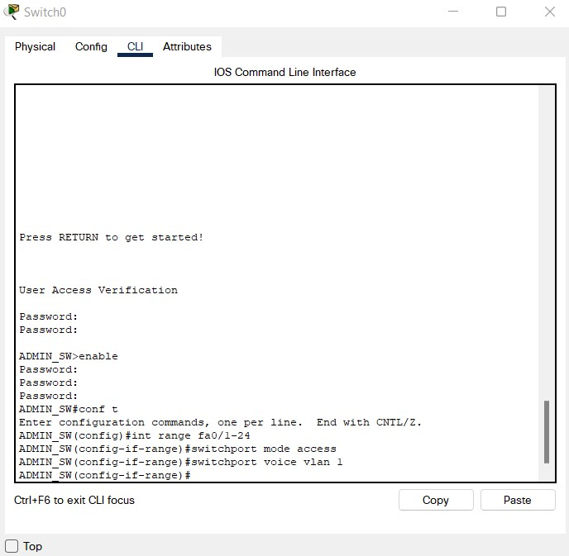
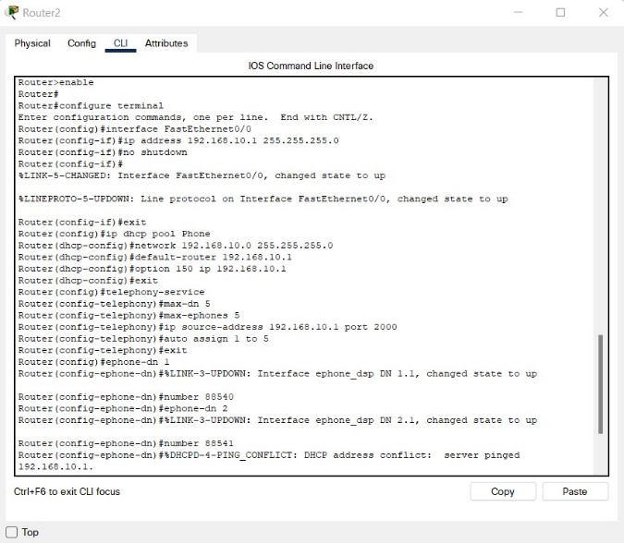

Fig 3 Router2-IP Phone
Fig 4 Switch0-Vlan

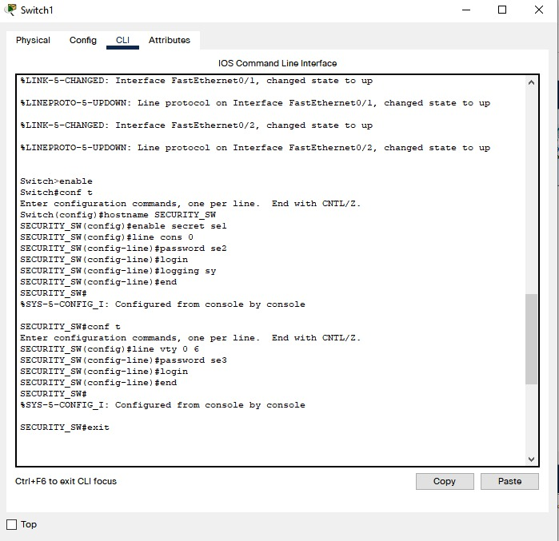
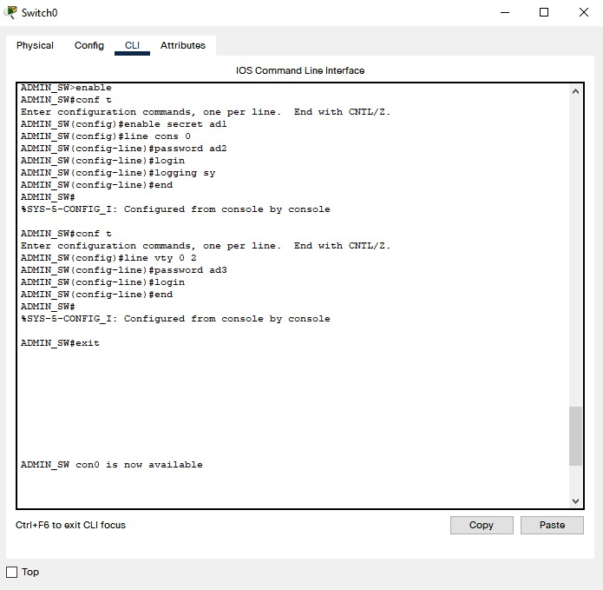
Fig 5 Switch0-passwords
Fig 6 Switch1-passwords

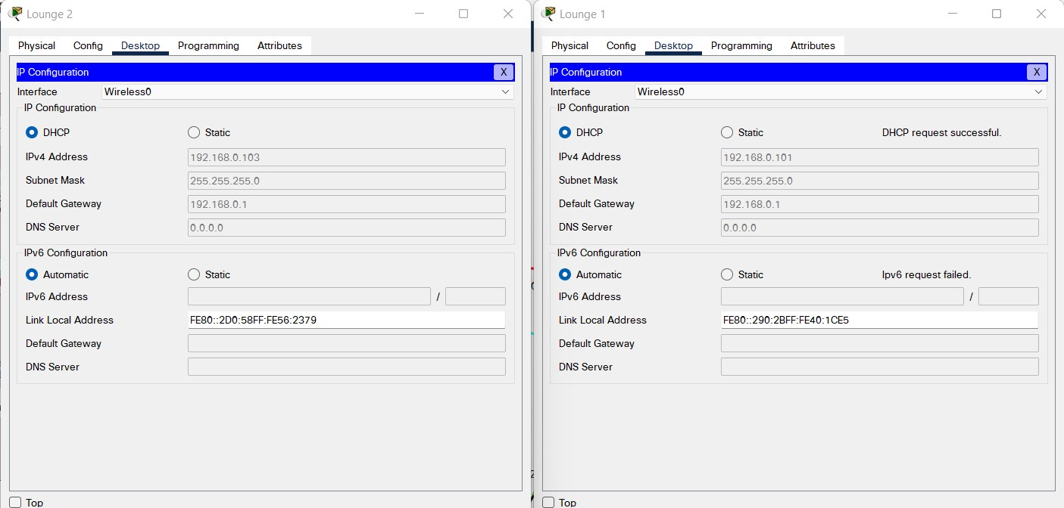
Addressing of devices:
Fig 7 IPs
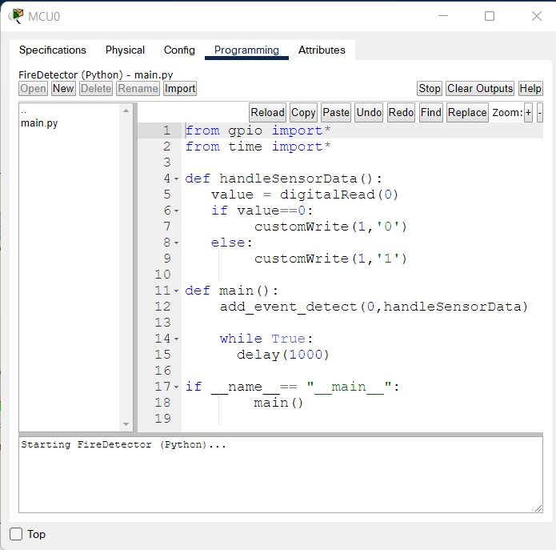
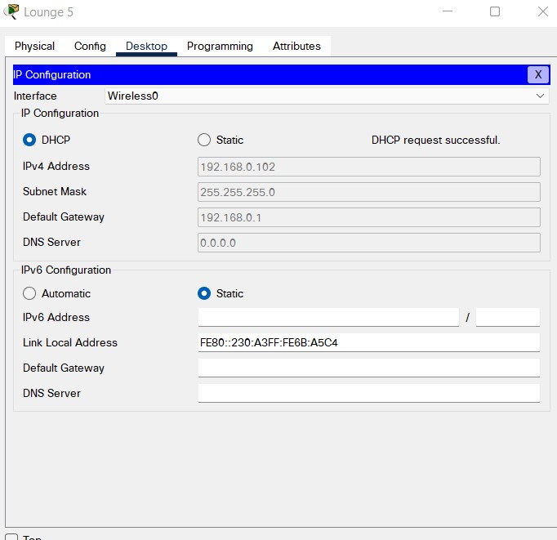
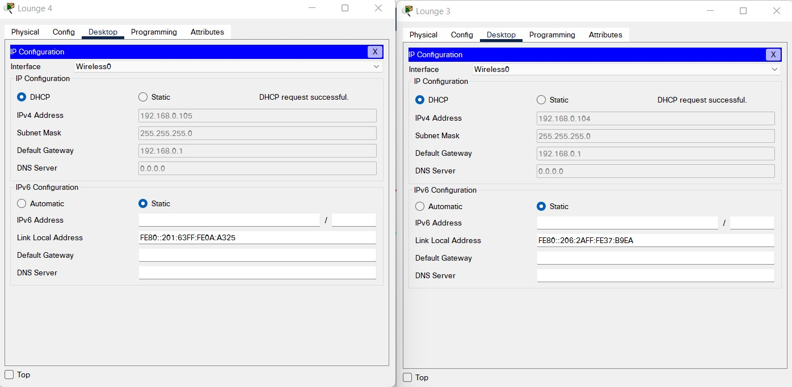
Fig 9 IPs
Fig 8 IPs
Fig 10 MCU code

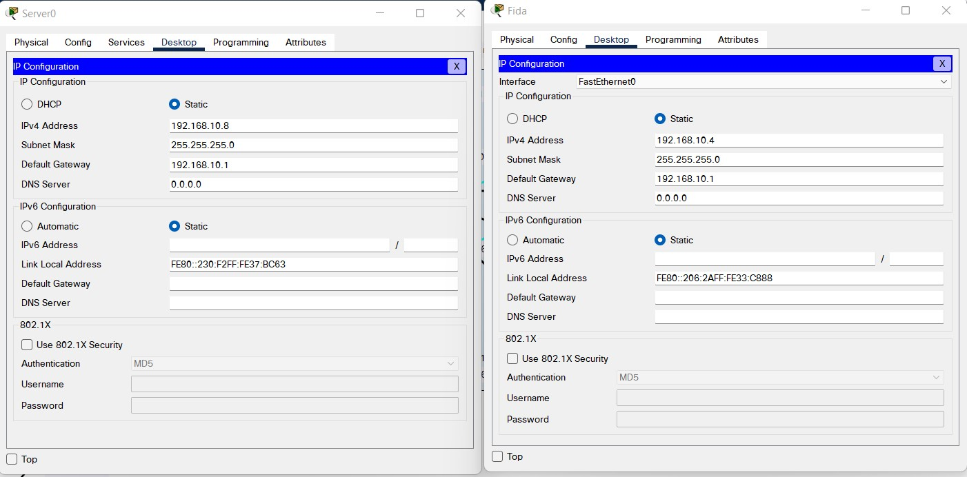
Fig 11 IPs

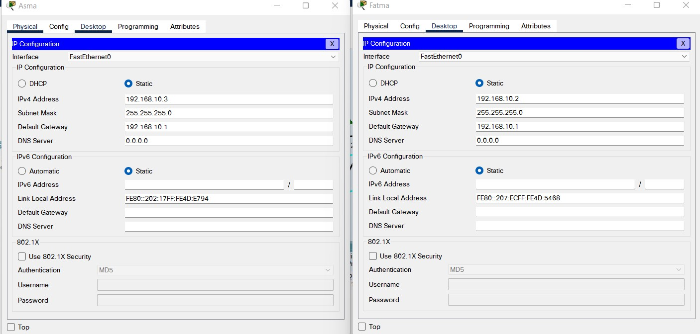
Fig 12 IPs

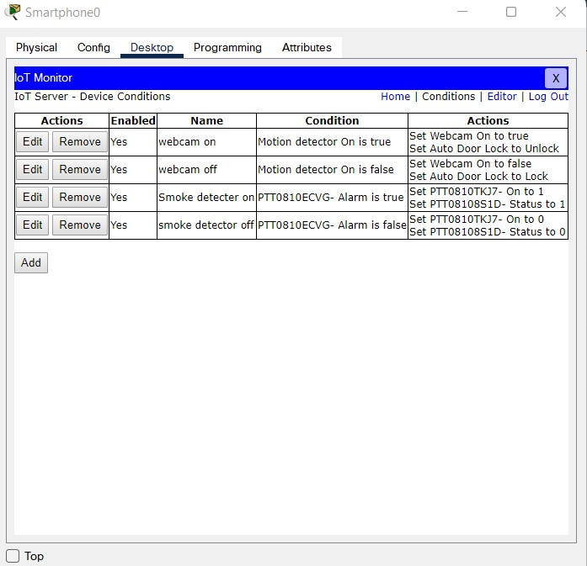

Fig 13 conditions for systems
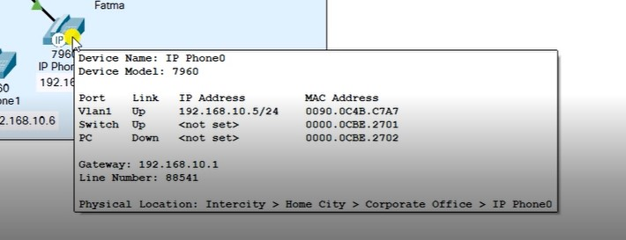
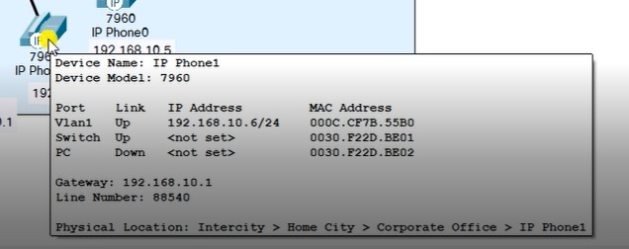
Fig 14 IP phone 0 (IP and Line number)

Fig 15 IP phone 1 (IP and Line number)

YouTube link: https://youtu.be/UDFj25usAkw

